[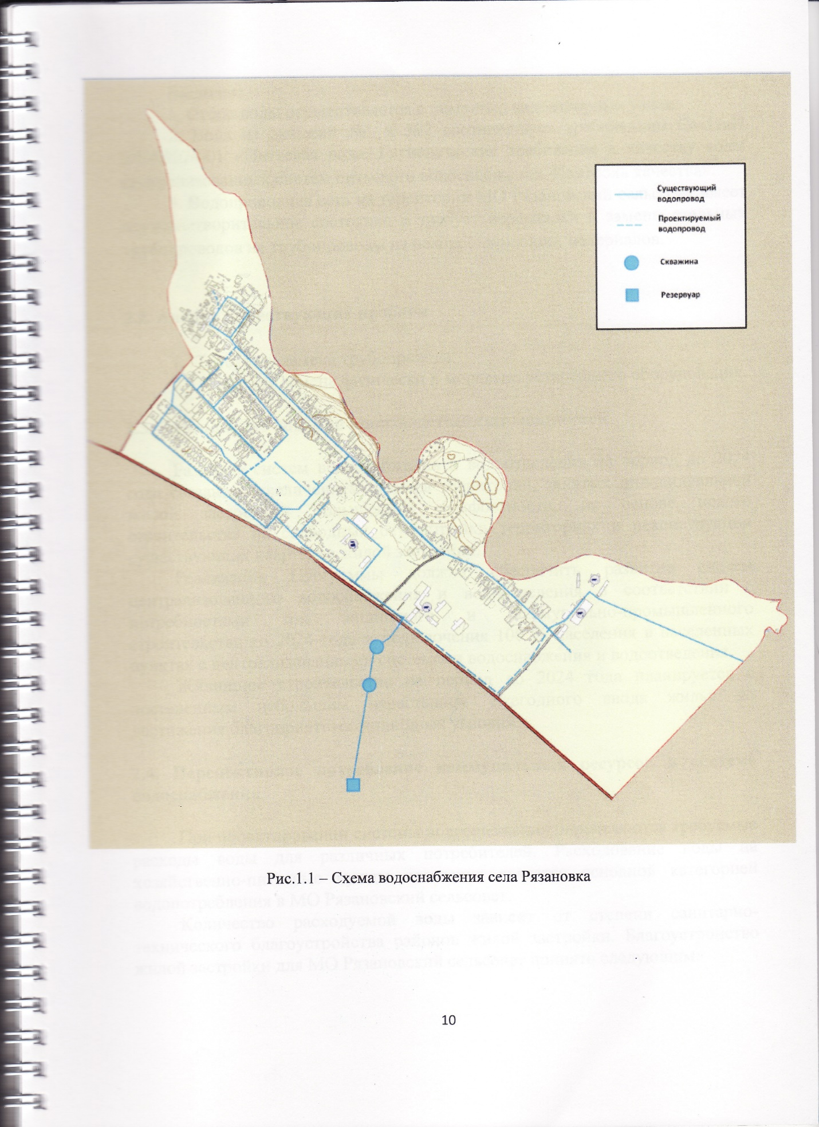](https://аморс.рф/sites/default/files/img_0001.jpg)